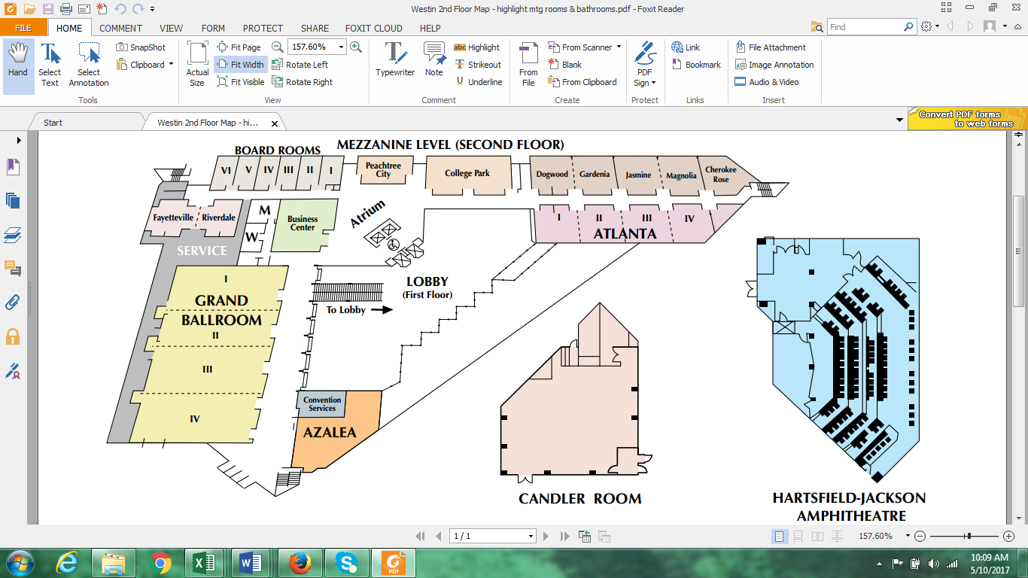

**Candler Room for Friday Mixer/Saturday Lunch**

Friday Book Fair

Q&A Panels, Workshop, Talks &

Award Ceremony

**Go to Lobby for:**

- Additional computers with printer

- ATM

- Coffee, snacks & sundries

- Self-parking payment

- Restaurant & bar

Elevators

Restaurant

Rest -rooms